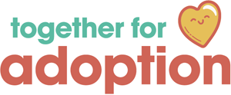

Consent to Share Information.

- I/we give my/our consent to TFA consulting with relevant agencies in order to obtain information regarding my/my child(ren)’s birth history and pre/post-adoption experiences.

- I/we give my/our consent to TFA sharing my/our Assessment of Adoption Support Needs and Support Plan to relevant professionals.

- I/we understand that the assessment may lead to an Adoption Support Fund Application, using my/our child(ren’s) fair access amount of funding.
- I/we agree to maintain confidentiality of any virtual sessions with TFA employees, and will not video record sessions without prior discussion and written consent from TFA.

- I/We agree for our names and email address to be added to TFA’s mailing list.

Name of Child(ren):
Consent Given By:
Position:
Parents Signature:
TFA Worker
TFA Signature
Position:
Date:

